 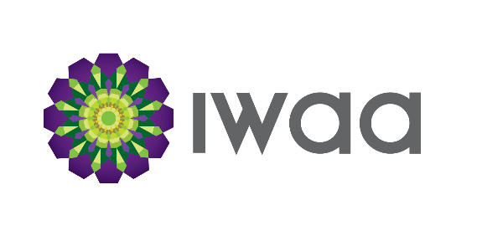

**Connected Women Leadership Program Registration Form**

**Every Saturday, starting 4th August 2018**

**10 am-1pm at IWAA Hall, 11 Watland Street, Springwood**

|  |  |  |  |
| --- | --- | --- | --- |
| **PARTICIPANT INFORMATION** | | | |
| Name | | | Age |
| Address | | | |
| Contact No: | | Email | |
| Health Information | | | |
| Medication Requirements (Please bring these and clearly label them with your name and dosage |  | | |
| Any Allergies | Special Dietary Requirements (aside from Halal) | | |

|  |  |
| --- | --- |
| **IN CASE OF EMERGENCY** | |
| Name of Parents/Guardian | Contact No |

What do you hope to gain from attending this Program?

**Photo Release**

I, _______________________________________________do hereby give my consent and authorise the Queensland Police Services (QPS) and the Islamic Women’s Association of Australia (IWAA), legal representatives, assigns, and agents to use and reproduce the participant’s likeness (photographic, illustrative, audio or video tape, film or electronic and/or digital image), and circulate and use the same for any and all official resources, use, or purpose including but not limited to print, film, or electronic media and reproduction or digital representation of every description. Consideration is hereby waived in perpetuity, and no further claim of any nature whatsoever shall be made by me, my heirs or assigns. I understand that QPS and IWAA reserves the right to publish, reproduce, distribute and use for promotional purposes any videos, photographs and audio recordings of all participants enrolled in their programs. These materials shall be used without any compensation and are the property of QPS and IWAA. Photos, video and audio clips may appear on but are not limited to QPS and IWAA print materials, website, social media and other media outlets.

***The above information is true to the best of my knowledge.***

_______________________________________ ____________________________

Participant Signature Date

_______________________________________ ____________________________

Signature of Parent/Guardian if under 18 Date

***Places are limited. Please complete form and send to*** [***nora.cams@iwaa.org.au***](mailto:nora.cams@iwaa.org.au)