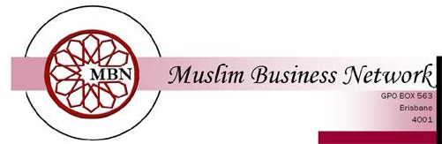

MBN TRIVIA NIGHT
SATURDAY 19 JULY 2008 - 6.00PM
SACRED HEART COMMUNITY CENTRE, 80 NEMIES RD, RUNCORN
ENTRY FORM

TEAM NAME:……………………………………………………………………………………………….
MEMBERS OF TEAM:
1…………………………………………………………………….………………………………………………….
2………………………………………………………………………………………………………………………..
3………………………………………………………………………………………………………………………..
4………………………………………………………………………………………………………………………..
5……………………………………………………………………………………..………………………………..
6………………………………………………………………………………………………………………………..
7……………………………………………………………………………………..............................
8………………………………………………………………………………………………………………………..
9………………………………………………………………………………………………………………………..
10……………………………………………………………………………………………………………………...
ENTRY FEE: $15 per person ($150 per team)
ENTRY FORMS TO BE HANDED IN BY 15 JULY 2008

